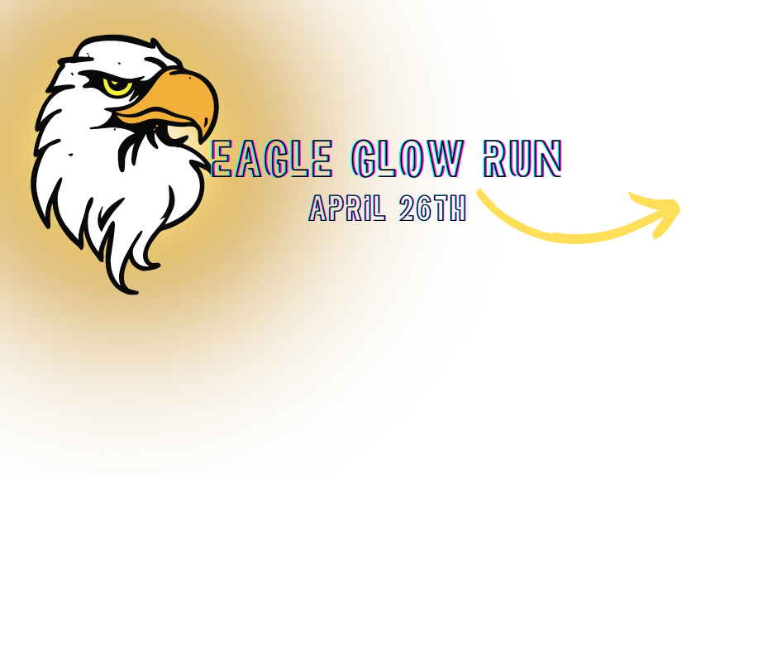

Student Run Packet

We’re excited to lace up our sneakers for this year’s Eagle Glow Run & Field Day! This packet provides you with everything you need to know about supporting your student racer as they raise funds to support St. Stephen School. You can also find more information on our website at

Eagle Glow Run | Friday, April 26th, 2024 | During the School Day
Our students run/walk laps to raise funds to help us continue to make important upgrades to our building in addition to further enhancing our curriculum.

This year, the money raised will be put towards restorative projects (both inside and outside!) and classroom and technology upgrades.

All students will receive a Glow Run/Field Day T-shirt to wear with their gym uniform bottoms and sneakers on Friday, April 26th thanks to our *community sponsors!

Eagle Glow Run Next Steps:

- On 4/10/24, you will receive an email (from 99pledges.com) with a link to your student’s fundraising page. Each student has a dedicated page so if you have more than one child, you will receive an email for each child.
- The school has pre-registered all students. Once you have the link, there is no need to register or login. Simply make a donation online and share the link on social media or email with friends and family! Prefer to mail a donation? Please see the donation form on page 3 in this packet.
- Continue to share the link to encourage donations and monitor your child’s progress. They are eligible for great classroom and schoolwide incentives and could win some really great prizes!

Please Note:
- You can always find your child’s page by searching his or her name at https://app.99pledges.com/fund/eagleglowrun
- You will see an option to “leave a tip” during the donation process. To bypass, choose Other and type “0”.

About those prizes!
To reward our students for their participation, we’re offering these prizes on top of classroom and school wide incentives!

Any student who:
- Collects over $25 will be entered into a drawing of their choice
- Collects over $50 will be entered into a second drawing
- Collects over $100 will be entered into a third drawing
- Collects over $150 will be entered into a fourth drawing
- Collects $200 or more will be entered into a fifth drawing
- Collects $250 or more will be entered into a sixth drawing
- Collects at least one donation earns a prize for the day of the Glow Run!

Prizes!:
Orioles Tickets | Electric scooter | Crocodile Cave Adventure Water Slide | Starbucks Gift Card
SSS Spiritwear Gift Card | Giant Connect Four | Movie Passes to Horizon Theaters | Fallston Mini Golf & Rita’s Gift card
Stanley Cup (student picks color) | Glow Basketball Hoop | $100 Dicks or Ulta Gift Card | Starbucks or Ice Cream break with 2 friends
Zumba class with Profe! | You get to pie Mrs. Kozlowski & Mrs. Liberto (2 winners!)
Carnival wristband voucher for the top earning student in each grade!
The top-earning homeroom will earn a dunkin’ breakfast!

And, if we reach our $50,000 goal, a school-wide pizza party!

*Thank you to our community sponsors for funding our shirts for the Glow Run/Field Day!
PoolCare Unlimited, LLC | Ocean Pride
Hydro Softwash | Bmore Technology
Classic Body & Fender | Cornerstone Recruiting
Matthew's Pizza | Amanda Gallagher Orthodontics
Riparius Construction, Inc. | Joppa Transmission & Auto Services
Baltimore North BeLocal
Posh Hair Studio | Christopher J. Seling & Associates, Inc.
Daisy Electric, LLC | The Sheffield Institute for the Recording Arts

